
Classic Surrounds LLC

INSTRUCTIONS
FOR CUTTING INTERIOR AND EXTERIOR PANELS

RECOMMENDED TOOL LIST

- SKILL SAW
- WOOD SKILL SAW BLADE
- DRY CUT MASONARY BLADE
- MEASURING TAPE
- CHALK LINE
- SAFETY GLASSES

- PLACE PANEL WITH BACKSIDE UP, STONE SIDE DOWN. ALL CUTS SHOULD BE PUT ON A SOFT CUTTING SURFSCE SUCH AS CARPET, STYROFOAM, ETC.(CUT PIECES NEED TO BE SUPPORTED WHILE CUT IS BEING MADE)
- MARK BACK PANEL TO BE CUT WITH CHAULK LINE.
- SET WOOD SKILL SAW BLADE TO 5/8 TO 11/16 MAX. (SEE FIG.1)
- MAKE CUT THROUGH WOOD.
- CHANGE WOOD BLADE TO MASONARY BLADE.
- SET MASONARY BLADE TO FULL CUT
- FOLLOW SAME CUT AS WOOD BLADE CUTTING THRU STONE.
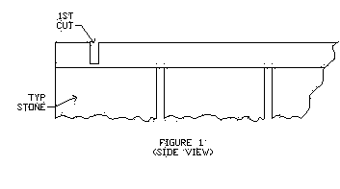
PAGE 10

