
Classic Surrounds LLC

INSTALLATION INSTRUCTIONS
STONE MANTEL

- INSTALL SURROUND
  - ATTACH SURROUND TO STUD WALL USING STANDARD PROCEDURE. LEAVE SCREWS AT TOP LOOSE TO ALLOW METAL FLANGE ON MANTEL TO SLIDE BEHIND.
- MOUNT MANTEL TO SURROUND
  - PLACE A BEAD OF **GROUT ON THE FULL LENGTH OF SURROUND.
  - PLACE STONE MANTEL ON SURROUND WITH SOMEONE ON EACH END MAKING SURE THE MANTEL ON SURROUND IS PLACED STRAIGHT DOWN ON THE TOP OF SURROUND. ALLOWING METAL FLANGE TO GO BEHIND SURROUND.
  - TIGHTEN TOP SCREWS ON SURROUND.

NOTE: GROUT WILL BE CURED 25% IN APPROXIMATELY 2 HRS. AND 100%
IN 24 HRS.
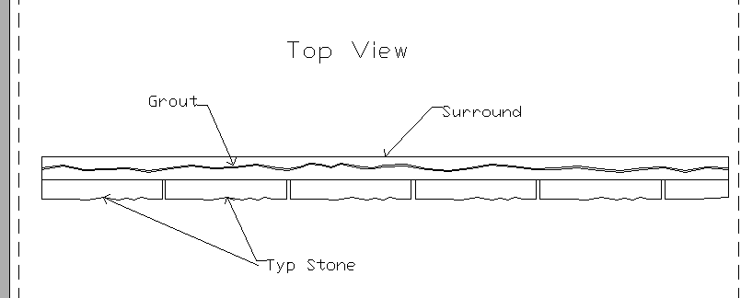
** USE “COLOR GROUT” OR EQUIVALENT ONLY PAGE 20

