
Classic Surrounds LLC

INSTALLATION INSTRUCTIONS
FOR SKIRTED CROWN MANTELS

- INSTALL HEARTH EXTENSIONS AND STONE SURROUND.
- SET MANTEL ON TOP OF SURROUND ALLOWING SKIRT TO CAP OVER SURROUND. (SEE ILLUSTRATION)
- MARK WALL OVER BUTTON HOLES WITH PENCIL.
- TAKE MANTEL DOWN
- MEASURE DOWN ¾” FROM MARKS.
- SECURE DEAD WOOD TO WALL WITH #8 x 3” WOOD SCREWS (MIN 2 PER STUD).
- PLACE MANTEL ON SURROUND ALLOWING TOP SHELF TO SET ON TOP OF DEAD WOOD.
- ATTACH MANTEL TO DEAD WOOD WITH #8 x 1-1/2” FLAT HEAD WOOOD SCREWS.
- FILL SCREW HOLES WITH PROVIDED BUTTONS.
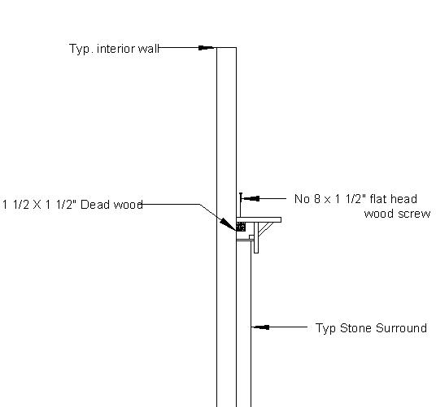
PAGE 32

