
Classic Surrounds LLC

INSTALLATION INSTRUCTIONS
ALABASTER SURROUND

- PLACE PLATFORM HEARTH ON FLOOR IN FRONT OF FIREBOX.
- SLIDE PLATFORM TO WITHIN APP. 3/8” FROM FIREBOX MAKING SURE THAT THE METAL EXTENSION THAT IS ON THE TOP ON THE HEARTH SLIDES UNDERNEATH FIREBOX.
- ATTACH METAL TRIM KIT AROUND FIREBOX USING BRADS SECURING TO STUD FRAMING.
- PLACE SURROUND ON TOP OF HEARTH ALLOWING METAL TABS SLIDE BEHIND HEARTH.
- ATTACH SURROUND AT TOP USING 2-3/4” SCREWS. MAKE SURE THAT SCREWS GO THROUGH SURROUND AND INTO STUD WALL. (1 SCREW ON EACH SIDE OF SURROUND).
- SLIDE HEARTH COMPLETELY TO FIREBOX.
- SECURE HEARTH TO FLOOR.
- PLACE FLAT BUTTONS IN LOCATIONS WHERE SCREWS WERE PLACED IN SURROUND. APPLY TOUCH-UP MIXTURE TO BUTTONS THAT ARE SUPPLIED.
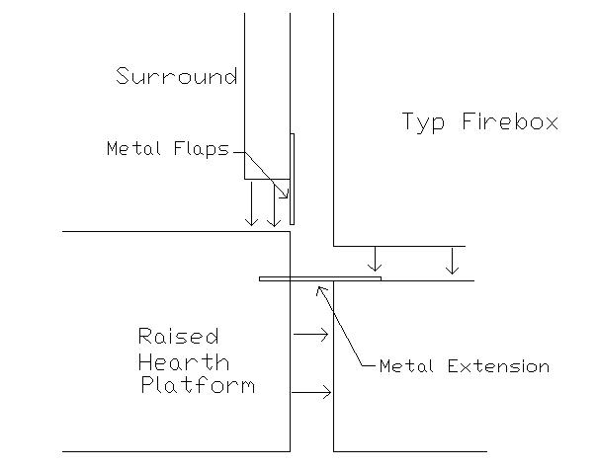
PAGE 35

